Greih Murray

Yolanda Brown

Fatih Suljovic

Boussofyane Ilboudo

New Client Report

The new client report lists all clients which have started working with the firm in the past six months. This report allows Wilson Financial to keep track of how their client base has been growing over the past six months, and after running the report several times in six month intervals Wilson Financial will also be able to track how their client base has been growing over a longer time frame, by comparing historical reports to the most recent versions.

Goal: Keeps track of every client who joined the firm within the last six months. Advantages: Assists Wilson Financial in tracking the expansion of their clientele over time. Long-term Tracking: The company can evaluate the success of their marketing and outreach initiatives as well as examine patterns in client acquisition by comparing past data and running the report on a regular basis.

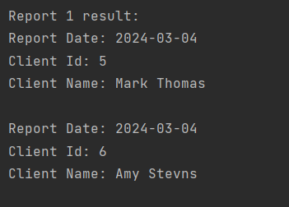

Average Asset Report

The average asset report will allow Wilson Financial to have an idea of the average value of their client’s assets, which is an important piece of information to know. As with the new client report, after having done this report several times in the chosen interval, Wilson Financial will then be able to track how the average valuation of their client’s assets has changed over time.

The information on the average asset value of clients is provided for this purpose. Advantages: Provides Wilson Financial with information about the general financial situation of their clientele. Long-term Tracking: The company can modify its services and investment strategies to better meet the needs of its clients by keeping an eye on changes in the average valuation of client assets over time.

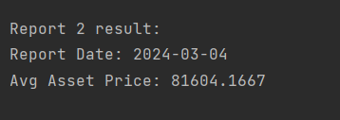

High Transaction Report

The high transaction report will allow Wilson Financial to track which of their clients have a higher than average (in this case 10 per month) transaction rate. This information will be helpful as more transactions will surely mean more work for Wilson Finacial to properly handle all transactions, and being able to know which clients have the higher transaction counts will allow the employees to properly disperse their time to cover all transactions for all clients.

The goal is to identify clients who transact more frequently than average (for example 10 transactions per month). Benefits: Gives clients with large transaction volumes priority in order to help allocate resources efficiently. Long-term tracking enables Wilson Financial to keep an eye on variations in client transaction activity over time and modify workflow and staffing procedures as necessary.

